**MAK STORE E-COMMERCE WEBSITE/PROJECT REPORT**

**A MAJOR PROJECT REPORT**

***Submitted by***

**MOHD AMAAN KHAN**

**2017-310-081**

***in partial fulfilment for the award of the degree of***

**BACHELOR OF TECHNOLOGY (B.TECH)**

***Under the supervision of***

**MS. ANAM SAYIEDA**



**Department of Computer Science & Engineering**

**School of Engineering Sciences & Technology**

**JAMIA HAMDARD**

**(Deemed to be University)**

**New Delhi-110062**

**(2020)**

**DECLARATION**

I, **Mr. MOHD AMAAN KHAN a student of Bachelor of Technology in Computer Science (B.Tech), (Enrolment No:2017-310-081)** hereby declare that the dissertation entitled **“MAK STORE (ECOMMERCE WEBSITE) ”** which is being submitted by me to the Department of Computer Science, Jamia Hamdard, New Delhi in partial fulfilment of the requirement for the degree of **Bachelor of Technology in Computer Science (B.Tech),** is my original work and has not been submitted anywhere else for the award of any Degree, Diploma, Associateship, Fellowship or other similar title or recognition.

**Date: 10th December, 2020 MOHD AMAAN KHAN**

**Place: Jamia Hamdard (2017-310-081)**

**ACKNOWLEDGMENT**

It is my great pleasure to present this project report **“ MAK STORE ( E-COMMERCE WEBSITE)”** which is the outcome of my sincere endeavour and countless supports from several people who helped me through their suggestion and inspired throughout the project development.

First of all, I would like to thank **Ms. Anam Sayieda** Asst. Prof, Department of Computer Science, Project Supervisor for creating opportunities to undertake us in the esteemed organisation and for all the help and guidance extended to me by her in every stage during the work. Her inspiring suggestions and timely guidance enabled me toperceive the various aspects of the project in a new light.

My sincere thanks to my family, my friends and others too and last but not the least my esteemed university, **Jamia Hamdard** that gave me an opportunity and infrastructure to carry out this project.

Finally, I thank every person who helped me in collection of data during development of the project without which this project would have not been possible.

**Mohd Amaan Khan**

**Date : 10/12/2020**

**Table of Contents**

**Page no**

* **Objective 5**
* **Abstract 6**
* **Introduction 7**
* **Problem Statement 8**
* **Software Requirement Specification 9**
* **Data flow Diagram 12**
* **Entity Relationship Diagram 13**
* **Snapshots 14**
* **Conclusion 22**
* **Bibliography 23**

1. **OBJECTIVE**

The main aim to build this project is to provide an easy way for all the customers who are looking for a hassle free shopping experience. The website not only provides all the details of various mobile phones and headphones the customer is looking for, but also this website keeps updating the customers of all the new phones and headphones that are newly launched under its blog section.

The website is designed to help all the customers who are willing to do online shopping.

**2. ABSTRACT**

The project titled “MAK STORE (E-commerce website)” is basically an online shopping website related to sports wear and clothing. In the world of today where digitalization is the major goal, most of the people are preferring online shopping over offline. Online shopping tends to save a lot of time and energy of the people and good things become just a click away.

This website is built on Html, CSS, JavaScript, Sass and Bootstrap and many more frameworks to provide good user-interface and helps in easy updating of contents. This website is also made on Node.JS . And the interesting thing about this website is that it’s fully Responsive website.

**3. INTRODUCTION**

With the world getting digitalized with every passing day. It is highly important to go online. This website which is an E-Commerce website is made for one such use. People tend to use lots of energy in offline shopping. Not only energy but a lot of time as well. This website tends to give a hassle free experience to its users.  
The customers can look for any Gym product or clothing item they wish to purchase. The website allows them to scroll the page, change the page, look the particular item. Once they find the item they can view the details and if interested they can save that item to their cart. The customers can also make the search using the search option. They can make changes to the cart as well. Willingly they can add or subtract the quantity, and finally make the order.  
While using the website the customers can sign up using their email id and not only that on signing up they can avail a discount of 10%.

Under the blogging section, the customers can find all the news and latest information related to mobile phones and headphones.  
  
This website is build on Html, CSS, JavaScript, Sass and also Bootstrap. It is also made on NodeJS. And it’s also fully Responsive so if you wish to see this web site on different- different platform then you will find out it’s layout/interface is varied upon different platform.

**4. PROBLEM STATEMENT**

As the world is getting digitalized day by day, there is a great need for the world to go online.

Therefore, this “E-commerce website” is designed to help the customers by updating them with relevant information, clearing all the doubts of the customers and helping in all the search related queries. People can look, find and order whatever they wish too.

E-commerce provides an easy way to sell products to a large customer base. However, there is a lot of competition among multiple e-commerce sites. When users land on an e-commerce site, they expect to find what they are looking for quickly and easily. Also, users are not sure about the brands or the actual products they want to purchase. They have a very broad idea about what they want to buy. Many customers nowadays search for their products on Google rather than visiting specific e-commerce sites. They believe that Google will take them to the e-commerce sites that have their product.

Also, due to the current pandemic going on, it is almost impossible to shop physically and also difficult to get your daily supplies.

**5. SOFTWARE REQUIREMENT SPECIFICATIONS**

**FOR MAK STORE (E-COMMERCE):**

* **HTML**

Hypertext Markup Language (HTML) is the standard markup language for documents designed to be displayed in a web browser. It can be assisted by technologies such as Cascading Style Sheets (CSS) and scripting languages such as JavaScript.

HTML elements are the building blocks of HTML pages. With HTML constructs, images and other objects such as interactive forms may be embedded into the rendered page. HTML provides a means to create structured documents by denoting structural semantics for text such as headings, paragraphs, lists, links, quotes and other items. HTML elements are delineated by tags, written using angle brackets. Tags such as <img /> and <input /> directly introduce content into the page. Other tags such as <p> surround and provide information about document text and may include other tags as sub-elements. Browsers do not display the HTML tags, but use them to interpret the content of the page.

* **CSS**

Cascading Style Sheets (CSS) is a style sheet language used for describing the presentation of a document written in a markup language like HTML. CSS is a cornerstone technology of the World Wide Web, alongside HTML and JavaScript.

CSS is designed to enable the separation of presentation and content, including layout, colors, and fonts. This separation can improve content accessibility, provide more flexibility and control in the specification of presentation characteristics, enable multiple web pages to share formatting by specifying the relevant CSS in a separate .css file, and reduce complexity and repetition in the structural content.

* **JAVASCRIPT**

JavaScript is one of the core technologies of the World Wide Web. JavaScript enables interactive web pages and is an essential part of web applications. The vast majority of websites use it and major web browsers have a dedicated JavaScript engine to execute it.

As a multi-paradigm language, JavaScript supports event-driven, functional, and imperative (including object-oriented and prototype-based) programming styles. It has APIs for working with text, arrays, dates, regular expressions, and the DOM, but the language itself does not include any I/O, such as networking, storage, or graphics facilities. It relies upon the host environment in which it is embedded to provide these features initially only implemented client-side in web browsers, JavaScript engines are now embedded in many other types of host software, including server-side in web servers and databases, and in non-web programs such as word processors and PDF software, and in runtime environments that make JavaScript available for writing mobile and desktop applications, including desktop widgets.

* **BOOTSTRAP**

Bootstrap tutorial provides basic and advanced concepts of Bootstrap. Our Bootstrap tutorial is designed for beginners and professionals.

Bootstrap is the popular HTML, CSS and JavaScript framework for developing a responsive and mobile friendly website. Our Bootstrap tutorial includes all topics of Bootstrap such as jumbotron, table, button, grid, form, image, alert, wells, container, carousel, panels, glyphicon, badges, labels, progress bar, pagination, pager, list group, dropdown, collapse, tabs, pills, navbar, inputs, modals, tooltip, popover and scrollspy.

* **SAAS**

Software as a service (SaaS) allows users to connect to and use cloud-based apps over the Internet. Common examples are email, calendaring and office tools (such as Microsoft Office 365).

SaaS provides a complete software solution which you purchase on a pay-as-you-go basis from a [cloud service provider](https://azure.microsoft.com/en-in/overview/choosing-a-cloud-service-provider/). You rent the use of an app for your organization and your users connect to it over the Internet, usually with a web browser. All of the underlying infrastructure, middleware, app software and app data are located in the service provider’s data center. The service provider manages the hardware and software and with the appropriate service agreement, will ensure the availability and the security of the app and your data as well. SaaS allows your organization to get quickly up and running with an app at minimal upfront cost.

* **Node.js**

**JavaScript** is the only language that Node.js supports natively, but many compile-to-JS languages are available. As a result, Node.js applications can be written in CoffeeScript, Dart, TypeScript, ClojureScript and others. Node.js is primarily used to build network programs such as Web servers.

**6. TOOLS/ENVIRONMENT USED**

The program needs some hardware and software requirements to run the website which are listed below:

**1. Hardware requirements**

* Processor – i3
* Hard Disk – 5 GB
* Memory – 1GB RAM
* Android device, iOS

**2. Software requirements**

* Sublime text
* Visual Studio Code
* Google Chrome

**7.DATA FLOW DIAGRAM**

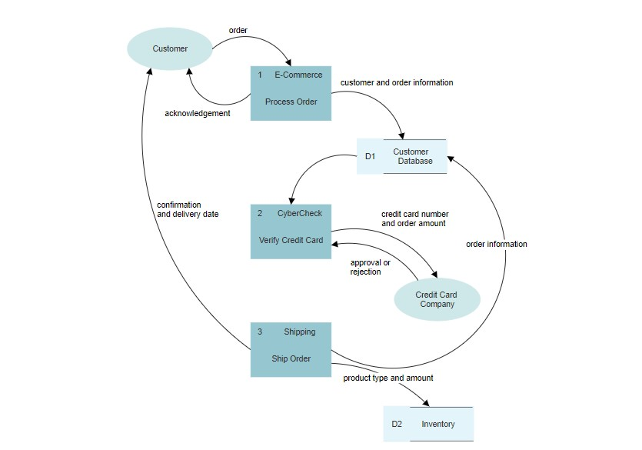

**8. E R DIAGRAM**

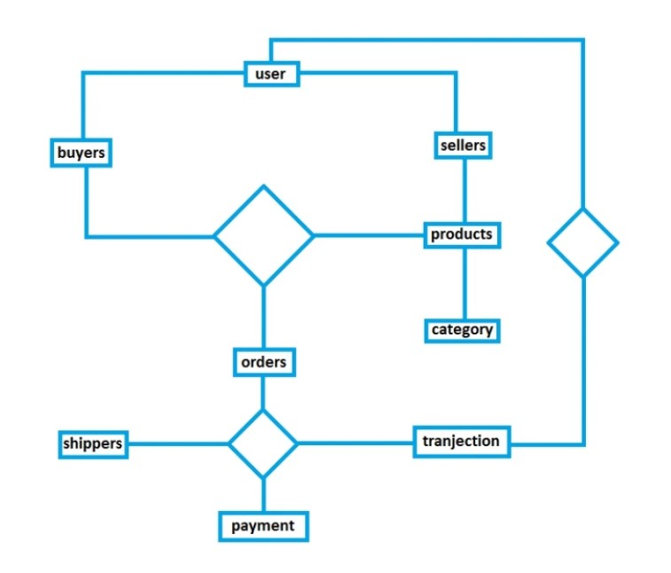

**9. SNAPSHOTS**

**Header (Nav-Bar) Snapshots**

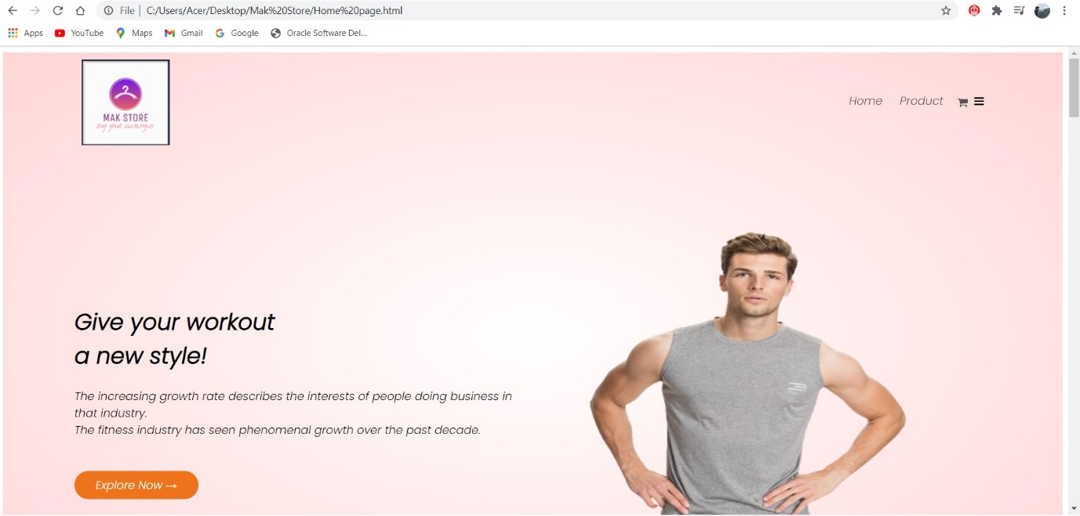

**Desktop View**

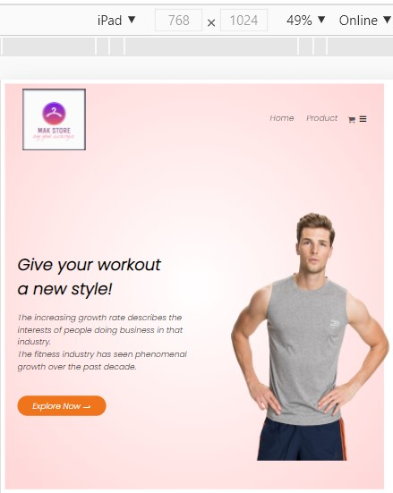

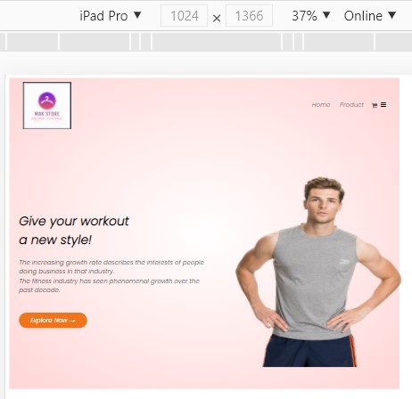

**Tablet View Mobile phone View**

**Products Categories Snapshots**

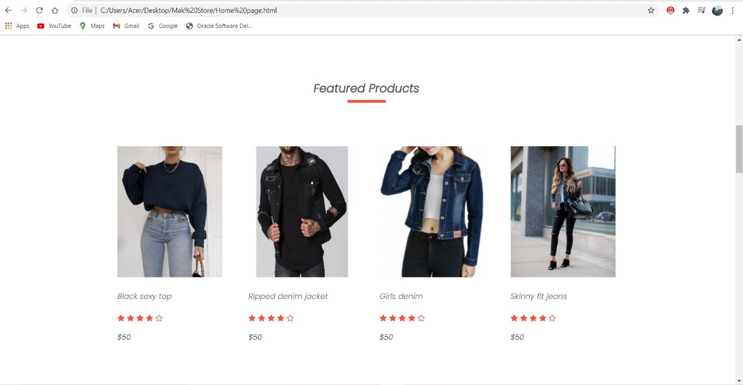

**Desktop View**

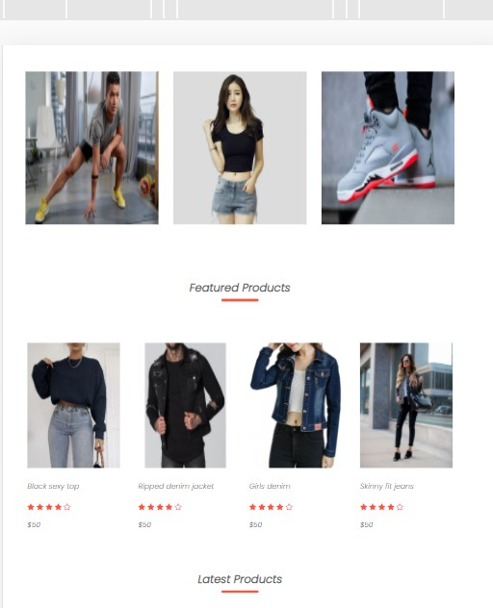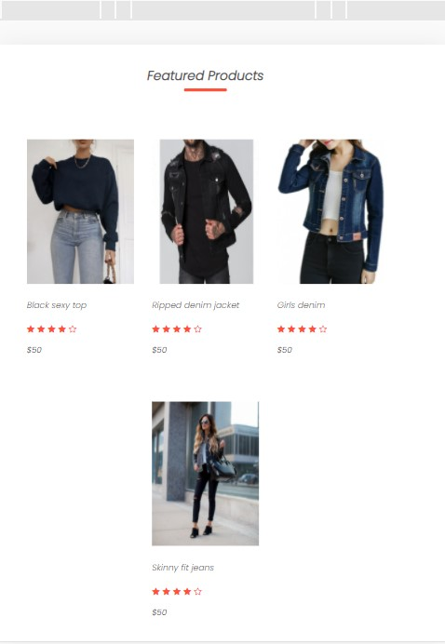

**Tablet View Mobile phone view**

**Testimonial Section Snapshots**

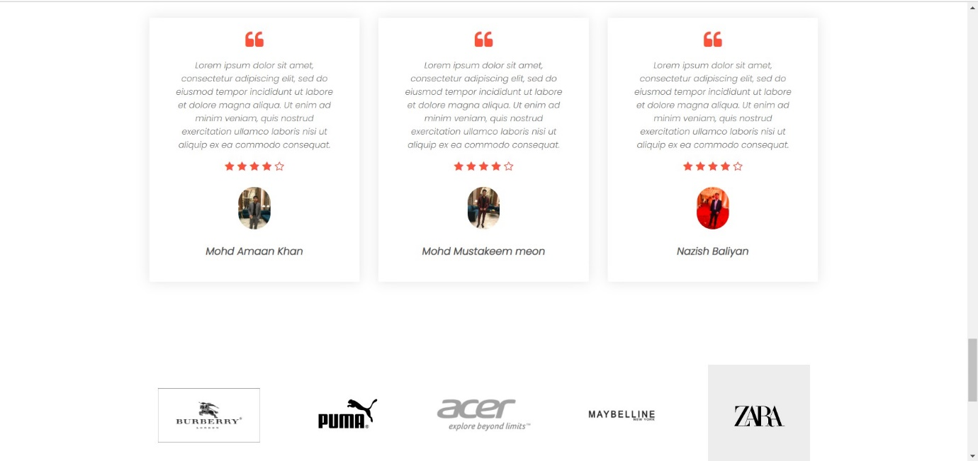

**Desktop View**

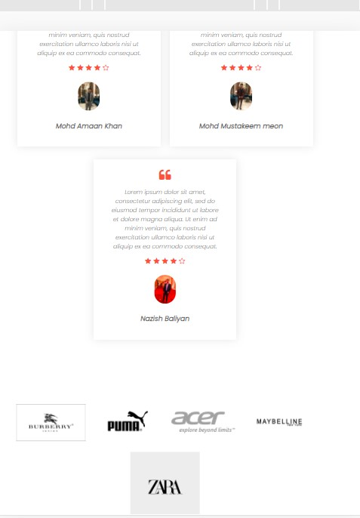

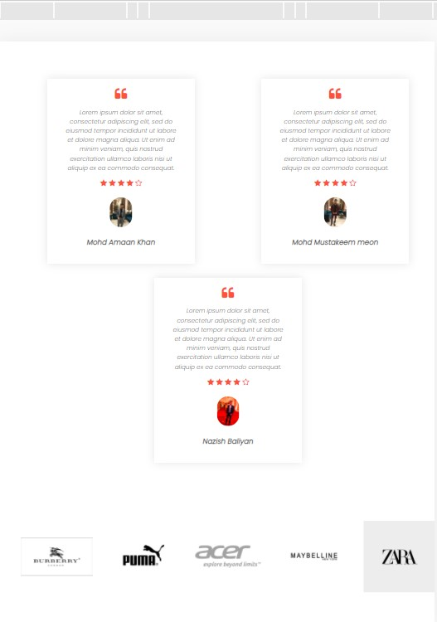

**Tablet View Mobile Phone View**

**Footer Section / contact us section Snapshots**

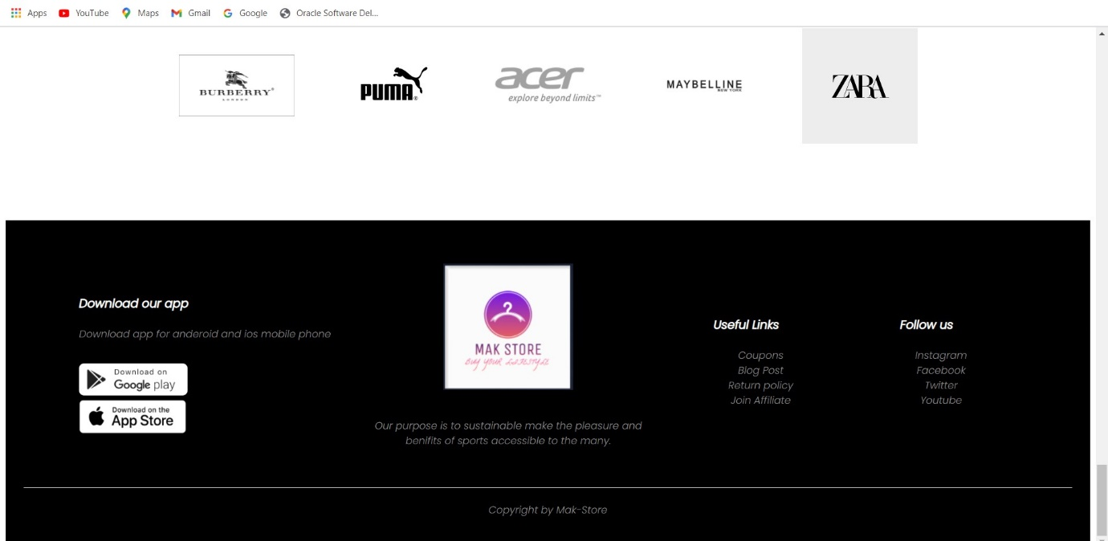

**Desktop View**

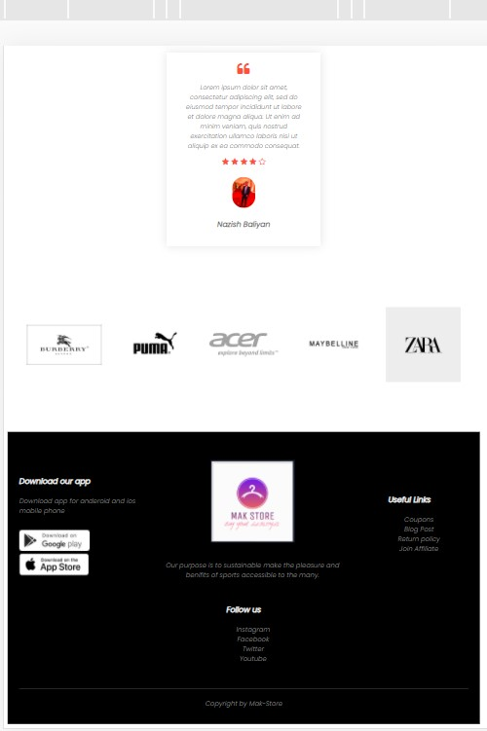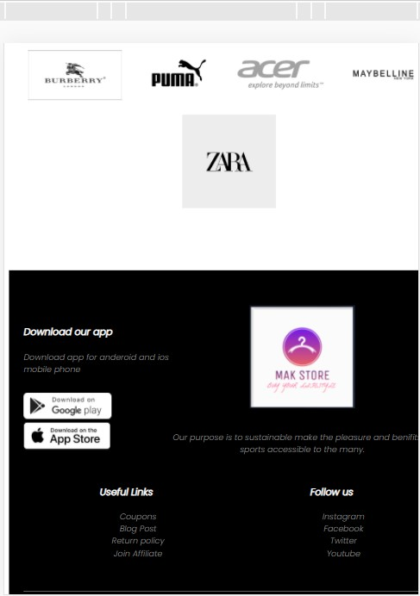

**Tablet View Mobil phone View**

**Product Details Snapshots-**

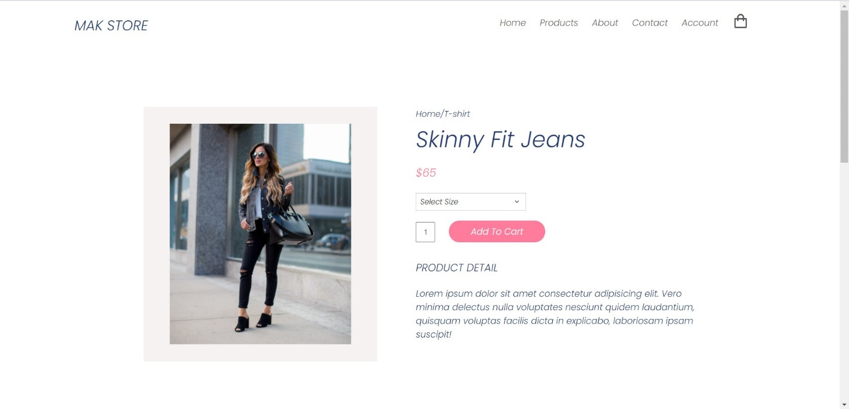

**Products Add to Card Snapshots**

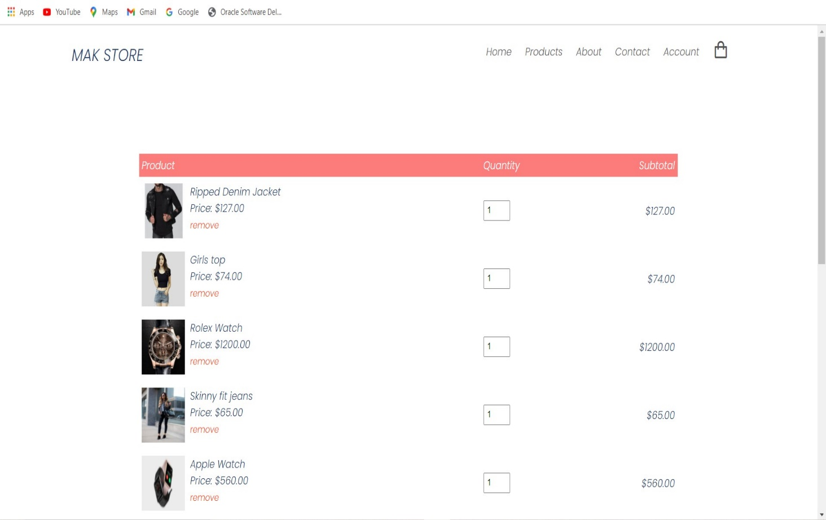

**9.CODE SNIPPET**

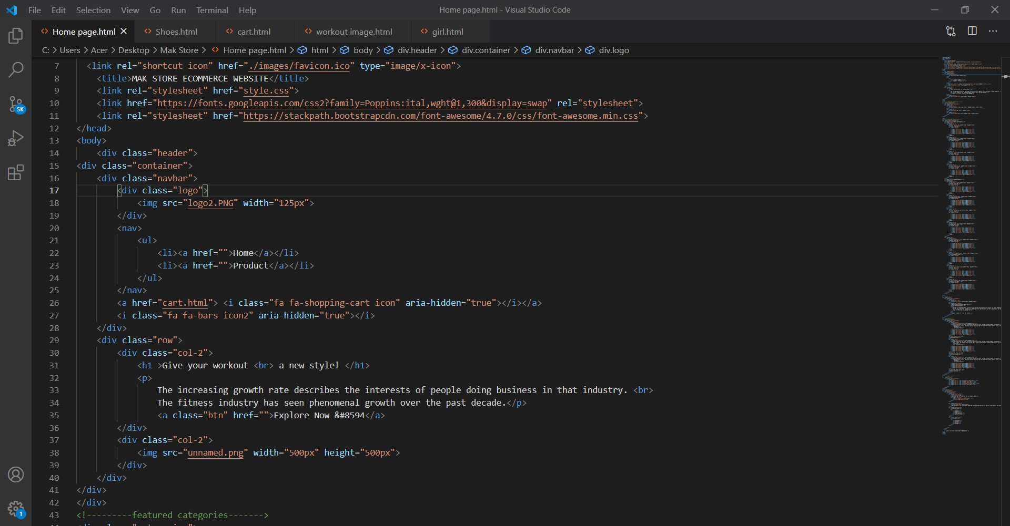

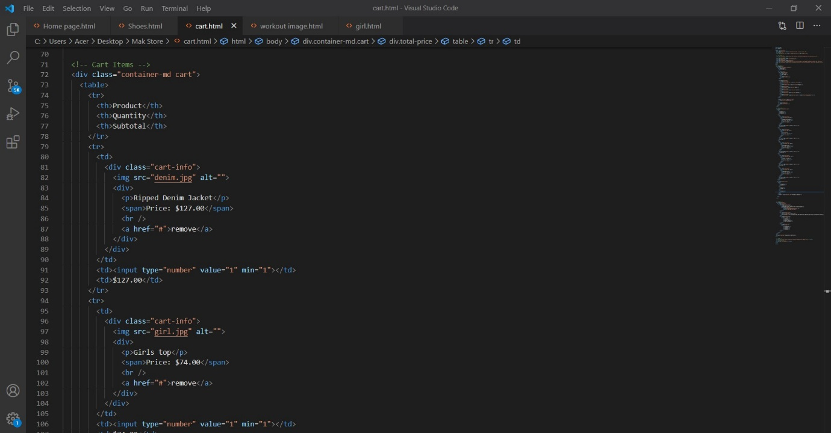

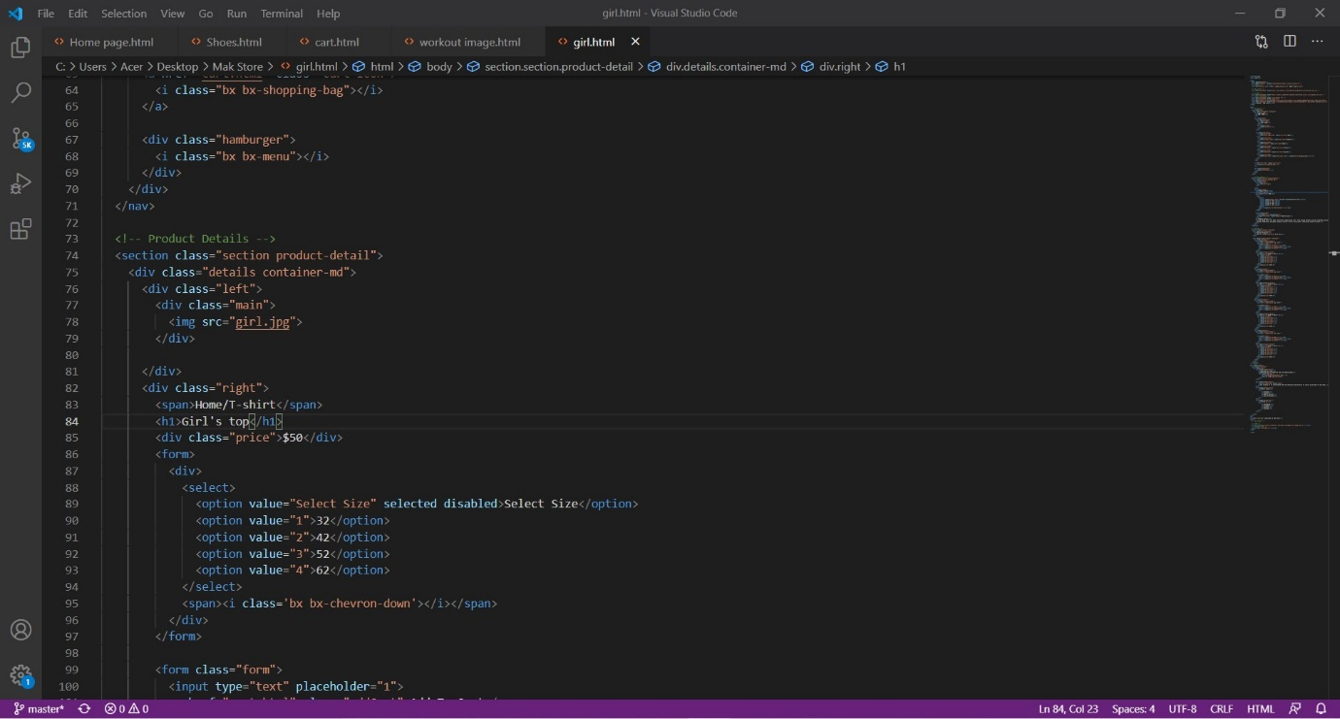

**10. CONCLUSION**

This project has helped the society in getting digitalized and going online. The customers can customize their orders, make the order, change the order everything with their wish.

The project is useful due to its cost effective and user friendly nature. It is technically free to use and very helpful to today’s technology dependent generation who obtain all their knowledge from the internet.

It could be extended further and improvised as per the team requirements.

**11. BIBLIOGRAPHY**

* <https://www.w3schools.com/>
* <https://getbootstrap.com/>
* <https://azure.microsoft.com/en-saas/>
* <https://www.javascript.com/>
* <https://www.wikipedia.org/>
* <https://formspree.io/>
* <https://youtube.com/>